**SOFTWARE REQUIREMENT SPECIFICATION** **DOCUMENT**

**JAVA APPLICATION CALCULATOR**

# **Version:** Version 1.0

**ABSTRACT**

# This document is intended to be the SRS for develop **JAVA APPLICATION CALCULATOR**

|  |  |  |  |
| --- | --- | --- | --- |
| **Project Title** | **JAVA APPLICATION CALCULATOR** | | |
| **Lead Institution** | **THE INTERNATIONAL SCHOOL - DUY TAN UNIVERSITY** | | |
| **Project Mentor** | **Mr. Nguyen Dang Quang Huy** | | |
| **Team Name** | **Team 2** | | |
| **Team Members** | **Nguyen Minh Nguyen** | | |
| **Nguyen Van Tu** | | |
| **Huynh Van Thien** | | |
| **Nguyen Phuc Sang** | | |
| **Ngo Xuan Bach**  **Nguyen Thi To Loan** | | |
| **Start Date** | March 03,2025 | **End Date** | March 10,2025 |

**ROPRIETARY INFORMATION**: The information contained in this document is the property of **TEAM 2**.

Except as specifically authorized in writing by **TEAM 2**, the holder of this document shall keep all information contained herein confidential and shall protect same in whole or in part from disclosure and dissemination to all third parties

# Contents

Revision History .................................................................................................................................................... 5

1. **Introduction** ...................................................................................................................................................... 7
   1. **Purpose** .......................................................................................................................................................... 7
   2. Target Audience and Usage Guide ................................................................................................................ 7
   3. References ...................................................................................................................................................... 7
2. Project Overview ................................................................................................................................................. 7
   1. Project Description ......................................................................................................................................... 7
   2. Business Need ................................................................................................................................................ 8

Business Function Diagram ................................................................................................................................. 8

System Context Diagram ..................................................................................................................................... 9

Software Requirement Specification .................................................................................................................. 10

High level Functional Requirement (FR) ........................................................................................................... 10

Stakeholders ....................................................................................................................................................... 11

Use case.............................................................................................................................................................. 11 List of use case ................................................................................................................................................... 12

**2.4.5.Use Case Specification** ............................................................................................................................ 13

UC 01: Perform addition .................................................................................................................................... 13

Perform addition ................................................................................................................................................ 13

UC.02: Perform subtraction ............................................................................................................................... 14

UC.03: Perform multiplication........................................................................................................................... 16

UC.04: Perform division .................................................................................................................................... 17

UC.05: Perform exponentiation ......................................................................................................................... 18

UC.06: Perform square root calculation ............................................................................................................. 20

UC.07: Perform percentage calculation ............................................................................................................ 21

UC.08: Delete 1 character .................................................................................................................................. 23

UC.09: Clear the entire calculation .................................................................................................................... 24 Clear the entire calculation................................................................................................................................. 25

2.4.6 . Activity Diagrams ................................................................................................................................... 27

Perform addition ................................................................................................................................................ 27

Perform subtraction ............................................................................................................................................ 28

Perform multiplication ....................................................................................................................................... 29

Perform division ................................................................................................................................................. 30

Perform exponentiation ...................................................................................................................................... 31

Perform square root calculation ......................................................................................................................... 32

Perform percentage calculation .......................................................................................................................... 33

Delete 1 character ............................................................................................................................................... 34

Clear the entire calculation................................................................................................................................. 35

Appendix A: Glossary .......................................................................................................................................... 35

Revision History

|  |  |  |  |  |
| --- | --- | --- | --- | --- |
| **Date** | **Change Iterm** | **Description** | **by** | **Version** |
| **03/03/2025** | Get requests from customers | After preparing the questions about the request and received the request from the customer | Nguyen Minh Nguyen. | Version  1.0 |
| **04/03/2025** | Start team meeting | Meet and refer to a number of training points, read through the training points and focus on project implementation, the team can fully understand the system requirements to create | Nguyen Minh  Nguyen, Nguyen  Van Tu, Huynh  Van Thien,  Nguyen Thi To  Loan, Ngo Xuan Bach, Nguyen Phuc Sang. | Verison  1.0 |
| **05/03/2025** | Job analysis | Through specific requirements, analysis, clearly speaking, the leader needs to prepare in advance for the members. | Nguyen Minh Nguyen. | Verison  1.0 |
| **06/03/2025** | Share the work | Get BFD, contextual diagram, DFD level 1, DFD level 2,  The mandatory rules of the project | Nguyen Minh  Nguyen, Nguyen  Van Tu, Huynh  Van Thien,  Nguyen Thi To  Loan, Ngo Xuan Bach, Nguyen Phuc Sang. | Verision  1.0 |
| **06/03/2025** | Mr. Huy corrected | Fix BFD, DFD, USE CASE, font size, font pattern, context diagram, more clearly about the missing and suggest some important things | Nguyen Minh Nguyen. | Verision  1.0 |
| **07/03/2025** | Editing group | BFD, DFD, USE CASE,  Context Diagram, font size, font | Nguyen Minh  Nguyen, Nguyen  Van Tu, Huynh  Van Thien,  Nguyen Thi To  Loan, Ngo Xuan Bach, Nguyen Phuc Sang. | Verision  1.0 |
| **08/03/2025** | Complete DFD,  System Context  Diagram | DFD 1 and 2, System Context Diagram | Nguyen Minh  Nguyen, Nguyen  Van Tu, Huynh  Van Thien,  Nguyen Thi To  Loan, Ngo Xuan Bach, Nguyen Phuc Sang. | Verision  2.0 |

1. **Introduction**

**1.1 Purpose**

This documentation describes the Java Application Calculator, a simple yet efficient system designed to perform various mathematical calculations using Java. The purposes of this document are as follows:

* To provide project managers with an overview of the system and assist in project estimation.
* To outline architectural drivers and use cases in detail, enabling software architects, analysts, and designers to implement the system effectively.
* To support testers (QC) in writing acceptance tests and test plans to ensure system accuracy and reliability.
* To serve as a comprehensive guide for all stakeholders involved in the development, implementation, and maintenance of the Java Application Calculator.
* To document the enhancement of the application with advanced scientific operations such as factorial, logarithms, trigonometric functions, and expression evaluation.
* To include new user interface customization options like font and color selection, as well as dark mode and light mode.
* To describe additional control features such as keyboard shortcuts, Clear Entry (CE), backspace and forward editing capabilities.
* To specify error handling improvements and advanced input validation mechanisms for better user experience.
* To cover the introduction of persistent calculation history management, including saving, searching, and deleting historical entries.

1.3 References

## 2 Project Overview

2.1 Project Description

With the increasing demand for digital computing tools, having an accurate and accessible calculator is essential for various professional and academic needs. The Java Application Calculator has been developed to meet these requirements by providing users with both fundamental and advanced mathematical functions in a seamless and efficient manner.

The Java Application Calculator includes the following features:

* Basic arithmetic operations: addition, subtraction, multiplication, and division.
* Exponentiation.
* Square root calculation.
* Percentage computation.

The objectives of the project are to:

* Provide a lightweight and efficient computing tool that enables quick and accurate calculations.
* Ensure a user-friendly interface that enhances accessibility for all users.
* Develop a flexible and scalable system capable of supporting future improvements and feature expansions.

The Java Application Calculator is an essential tool for students, professionals, and anyone who needs precise and efficient calculations in their daily tasks.

2.2 Business Need

- This system offers several advantages:

* Supports users in performing mathematical calculations quickly and accurately.
* Provides a simple and intuitive interface, making it easy for users of all skill levels to operate.
* Ensures efficiency in executing various arithmetic operations, thereby reducing manual calculation errors.
* Designed to be lightweight, ensuring smooth performance without consuming excessive system resources.
* Built with scalability in mind, allowing for future enhancements and the addition of new features.
* Offers a structured and maintainable codebase, facilitating upgrades and modifications as needed.

Business Function Diagram

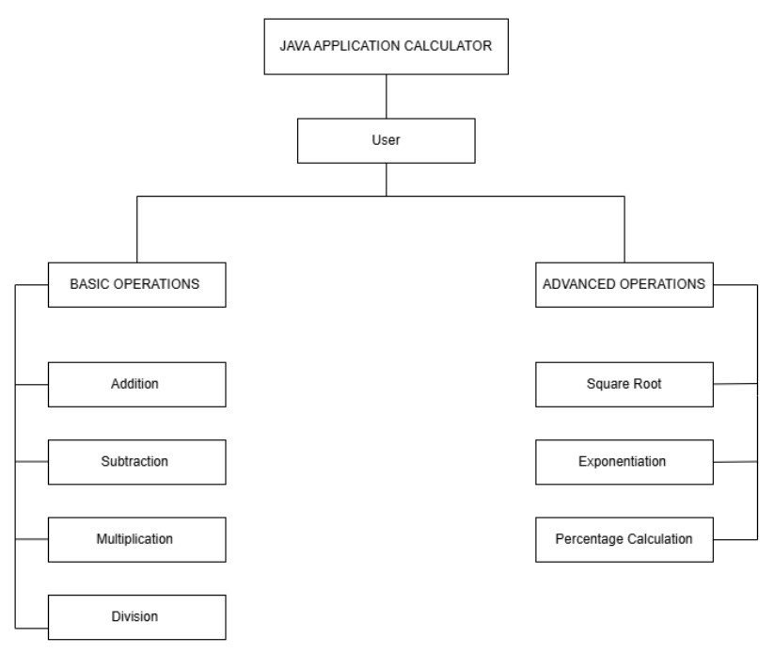

System Context Diagram

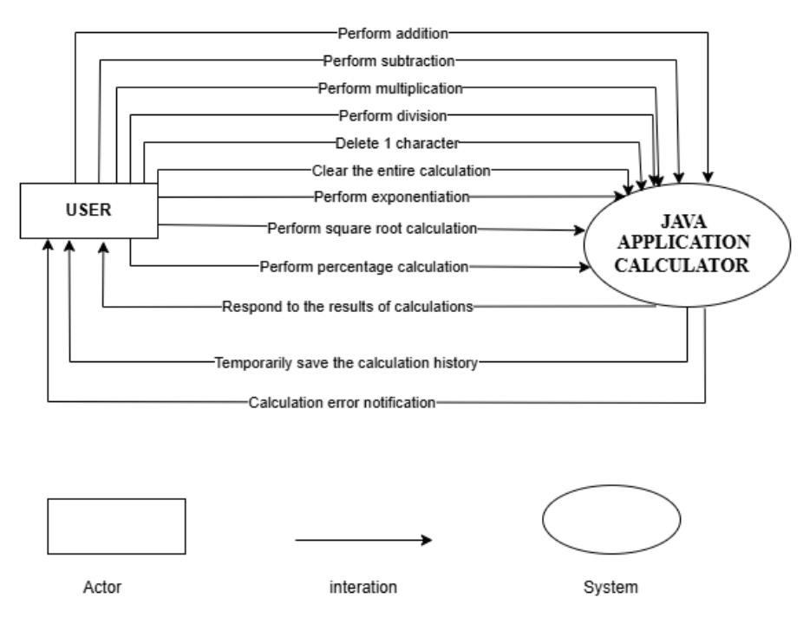

**Description**

* + **User can perform basic calculations** (addition, subtraction, multiplication, and division).
  + **User can perform advanced calculations** (exponentiation, square root, and percentage calculation).
  + **User can delete input** (delete one character or clear the entire calculation).
  + **User will receive real-time calculation results.**
  + **User will receive error notifications** (e.g., division by zero, invalid input).
  + **User can temporarily save calculation history** (view past calculations within a session).
  + **System ensures accurate and efficient calculations.**
  + **System provides a user-friendly interface** for easy interaction.

Software Requirement Specification

High level Functional Requirement (FR)

|  |  |  |
| --- | --- | --- |
| FR1.1 | **Title** | **Perform Addition** |
| User | Users utilize this function to perform addition operations. |
| Description | The system displays the main interface of the calculator. The user selects the addition function, inputs two numbers, and executes the operation. The system processes the inputs, calculates the sum, and displays the result. The use case ends. |
| FR1.2 | **Title** | **Perform subtraction** |
| User | Users utilize this function to perform subtraction operations. |
| Description | The system displays the main interface of the calculator. The user selects the subtraction function, inputs two numbers, and executes the operation. The system processes the inputs, calculates the difference, and displays the result. The use case ends. |
| FR1.3 | **Title** | **Perform multiplication** |
|  | User | Users utilize this function to perform multiplication operations. |
| Description | The system displays the main interface of the calculator. The user selects the multiplication function, inputs two numbers, and executes the operation. The system processes the inputs, calculates the product, and displays the result. The use case ends. |
| FR1.4 | **Title** | **Perform division** |
| User | Users utilize this function to perform division operations. |
| Description | The system displays the main interface of the calculator. The user selects the division function, inputs two numbers, and executes the operation. The system processes the inputs, calculates the quotient, and displays the result. If the divisor is zero, the system displays an error message indicating that division by zero is not allowed. The use case ends. |
| FR1.5 | **Title** | **Perform exponentiation** |
| User | Users utilize this function to perform exponentiation operations. |
| Description | The system displays the main interface of the calculator. The user selects the exponentiation function, inputs the base and exponent values, and executes the operation. The system processes the inputs, calculates the result of raising the base to the power of the exponent, and displays the output. The use case ends. |
| FR1.6 | **Title** | **Perform square root calculation** |
| User | Users utilize this function to calculate the square root of a number. |
| FR1.7 | Description | The system displays the main interface of the calculator. The user selects the square root function and inputs a number. The system processes the input, calculates the square root, and displays the result. If the input is a negative number, the system shows an error message indicating that the square root of a negative number is not supported. The use case ends. |
| **Title** | **Perform percentage calculation** |
| User | Users utilize this function to calculate percentage values |
| Description | **Description**: The system displays the main interface of the calculator. The user selects the percentage function and inputs the necessary values (e.g., a number and the percentage to calculate). The system processes the input, computes the percentage, and displays the result. The use case ends. |
| FR1.8 | **Title** | **Delete 1 character** |
| User | Users utilize this function to delete the last character of the current input. |
| Description | The system displays the main interface of the calculator. The user presses the "Delete" or "Backspace" button. The system removes the last entered character from the input field and updates the display accordingly. The use case ends. |
| FR1.9 | **Title** | **Clear All Characters** |
| Librarian | This use case allows librarians to issue books to readers |
| Description | The system displays the main interface of the calculator. The user presses the "Clear" or "C" button. The system removes all entered characters from the input field and resets the display. The use case ends. The system asks the librarian to enter additional information such as loan date and due date. In addition, the librarian provides this detailed information, the update system borrows |

Stakeholders

|  |  |  |
| --- | --- | --- |
| **Stakeholder** | **Description** |  |
| Users | System users | |

Use case

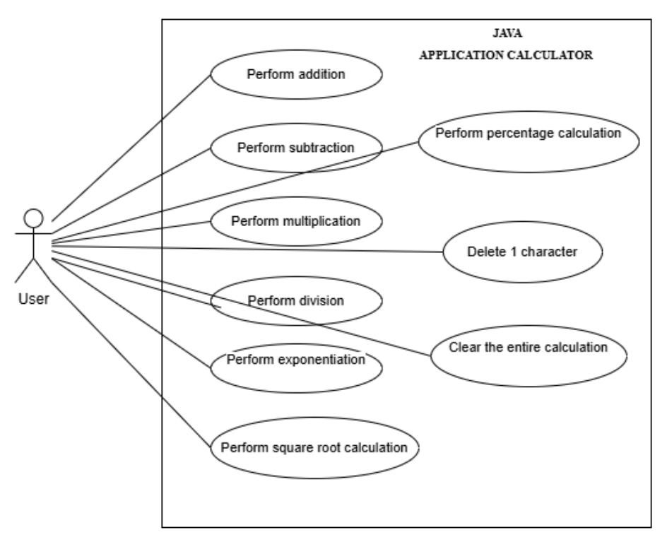

List of use case

|  |  |  |  |  |  |
| --- | --- | --- | --- | --- | --- |
| **Use case ID** | | | **Use case name** | | **Functional Req.** |
| UC.01 | Perform addition | | FR.1 | | |
| UC.02 | Perform subtraction | | FR.2 | | |
| UC.03 | Perform multiplication | | FR.3 | | |
| UC.04 | Perform division | | FR.4 | | |
| UC.05 | Perform exponentiation | | FR.5 | | |
| UC.06 | Perform square root calculation | | FR.6 | | |
| UC.07 | Perform percentage calculation | | FR.7 | | |
| UC.08 | Delete 1 character | | FR.8 | | |
| UC.09 | Clear the entire calculation | | FR.9 | | |

**2.4.5.Use Case Specification**

UC 01: Perform addition

* + - 1. Use Case Diagram

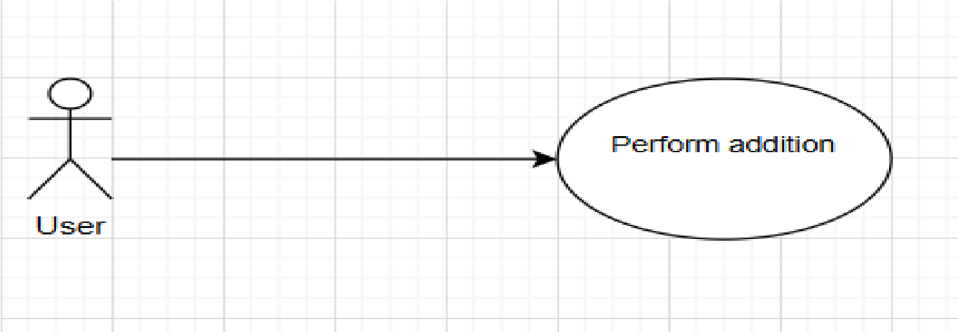

* + - 1. Use Case Specification

|  |  |  |  |  |  |
| --- | --- | --- | --- | --- | --- |
| **Use case ID** | UC.01 | | | | |
| **Use case name** | Perform addition | | | | |
| **Create by** | Van Tu | | **Last updated by** | | Van Tu |
| **Date created** | March,03, 2025 | | **Date last updated** | | March,03, 2025 |
| **Actor** | Users of the system, including: General Users | | | | |
| **Description** | This use case describes the process of performing an addition operation in the system. | | | | |
| **Trigger** | User selects the addition function in the calculator interface. | | | | |
| **Pre-condition** | The user has accessed the calculator interface. | | | | |
| **Post-condition** | If the use case is successful, the system displays the correct sum. If unsuccessful, an error message is shown. | | | | |
| **Main Success Scenario:** | **Step** | **Actor Action** | | **System Response** | |
| 1 | User enters the first number. | | The system accepts and displays the input. | |
|  | 2 | User selects the addition (+) operator. | | The system registers the operation. | |
| 3 | User enters the second number. User clicks the "=" button. | | The system accepts and displays the input.  The system calculates and displays the result. | |
| **Alternative Scenario** | **Step** | **Actor Action** | | **System Response** | |
| 1 | User enters only one number and presses "=". | | The system does not have enough input to perform addition. | |
| 2 | The system prompts the user to enter the second number. | | The user provides the missing number. | |
| 3 | The system performs the addition and displays the result. | | The process is completed. | |
| **Exception** | **Step** | **Actor Action** | | **System Response** | |
| 1 | User enters invalid characters (e.g., letters, symbols). | | The system detects invalid input and displays an error message. | |
| **Priority** | High | | | | |
| **Business rule** | N/A | | | | |
| **Description:** | Users can perform addition operations by entering numbers and selecting the addition operator. The system ensures accurate computation and displays the correct result. | | | | |

UC.02: Perform subtraction

* + 1. Use Case Diagram

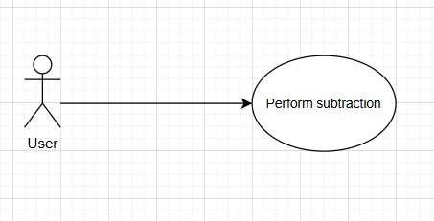

* + 1. Use Case Specification

|  |  |  |  |  |  |
| --- | --- | --- | --- | --- | --- |
| **Use case ID** | **UC.02** | | | | |
| **Use case name** | Perform subtraction | | | | |
| **Create by** | Van Tu | | **Last updated by** | | Van Tu |
| **Date created** | **March 04, 2025** | | **Date last updated** | | **March 04, 2025** |
| **Actor** | Users of the system, including: General Users | |  | | |
| **Description** | This use case describes the process of performing a subtraction operation in the system. | | | | |
| **Trigger** | User selects the subtraction function in the calculator interface. | | | | |
| **Pre-condition** | The user has accessed the calculator interface. | | | | |
| **Post-condition** | If the use case is successful, the system displays the correct difference. If unsuccessful, an error message is shown. | | | | |
| **Main Success Scenario:** | **Step** | **Actor Action** | | **System Response** | |
| 1 | User enters two numbers and selects the subtraction (-) operator. | | The system accepts and displays the input. | |
| 2 | User clicks the "=" button. | | The system calculates the result. | |
| 3 | The system displays the subtraction result. | | The process is completed. | |
| **Alternative Scenario** | **Step** | **Actor Action** | | **System Response** | |
| 1 | User enters only one number and presses "=". | | The system does not have enough input to perform subtraction. | |
| 2 | The system prompts the user to enter the second number. | | The user provides the missing number. | |
| 3 | The system performs the subtraction and displays the result. | | The process is completed. | |
| **Exceptions** | **Step** | **Actor Action** | | **System Response** | |
| 1 | User enters invalid characters (e.g., letters, special symbols). | | The system detects invalid input and displays an error message. | |
| 2 | User re-enters valid numerical values. | | The system accepts the input and allows the operation to proceed. | |
| **Priority** | High | | | | |
| **Business rule** |  | | | | |
| **Description:** | Users can perform subtraction operations by entering numbers and selecting the subtraction operator. The system ensures accurate computation and displays the correct result. | | | | |

UC.03: Perform multiplication

* + - 1. Use Case Diagram

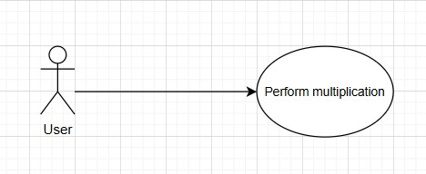

* + - 1. Use Case Specification

|  |  |  |  |  |  |
| --- | --- | --- | --- | --- | --- |
| **Use case ID** | **UC.02** | | | | |
| **Use case name** | Perform subtraction | | | | |
| **Create by** | Van Tu | | **Last updated by** | | Van Tu |
| **Date created** | **March 04, 2025** | | **Date last updated** | | **March 04, 2025** |
| **Actor** | Users of the system, including: General Users | | | | |
| **Description** | This use case describes the process of performing a multiplication operation in the system. | | | | |
| **Trigger** | User selects the multiplication function in the calculator interface. | | | | |
| **Pre-condition** | The user has accessed the calculator interface. | | | | |
| **Post-condition** | If the use case is successful, the system displays the correct product. If unsuccessful, an error message is shown. | | | | |
| **Main Success Scenario:** | **Step** | **Actor Action** | | **System Response** | |
| 1 | User enters two numbers and selects the multiplication (*) operator. | | The system accepts and displays the input. | |
| 2 | User clicks the "=" button. | | The system calculates the result. | |
| 3 | The system displays the multiplication result | | The process is completed. | |
| **Alternative Scenario** | **Step** | **Actor Action** | | **System Response** | |
| 1 | User enters only one number and presses "=". | | The system does not have enough input to perform subtraction. | |
|  | 2 | The system prompts the user to enter the second number.. | | The user provides the missing number. | |
| 3 | The system performs the subtraction and displays the result. | | The process is completed. | |
| **Exceptions** | **Step** | **Actor Action** | | **System Response** | |
| 1 | User enters invalid characters (e.g., letters, special symbols). | | The system detects invalid input and displays an error message. | |
| 2 | User re-enters valid numerical values. | | User re-enters valid numerical values. | |
| **Priority** | High | | | | |
| **Business rule** |  | | | | |
| **Description:** | Users can perform multiplication operations by entering numbers and selecting the multiplication operator. The system ensures accurate computation and displays the correct result. | | | | |

UC.04: Perform division

* + - 1. Use Case Diagram

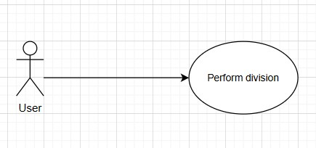

* + - 1. Use Case Specification

|  |  |  |  |  |  |
| --- | --- | --- | --- | --- | --- |
| **Use case ID** | **UC.02** | |  | |  |
| **Use case name** | Perform division | |  | |  |
| **Create by** | Van Tu | | **Last updated by** | | Van Tu |
| **Date created** | **March 04, 2025** | | **Date last updated** | | **March 04, 2025** |
| **Actor** | Users of the system, including: General Users | | | | |
| **Description** | This use case describes the process of performing a division operation in the system. | | | | |
| **Trigger** | User selects the division function in the calculator interface. | | | | |
| **Pre-condition** | The user has accessed the calculator interface. | | | | |
| **Post-condition** | If the use case is successful, the system displays the correct quotient. If unsuccessful, an error message is shown | | | | |
| **Main Success Scenario:** | **Step** | **Actor Action** | | **System Response** | |
| 1 | User enters two numbers and selects the division (/) operator. | | The system accepts and displays the input. | |
| 2 | User clicks the "=" button. | | The system calculates the result. | |
| 3 | The system displays the division result. | | The process is completed. | |
| **Alternative Scenario** | **Step** | **Actor Action** | | **System Response** | |
| 1 | User enters only one number and presses "=". | | The system does not have enough input to perform subtraction. | |
| 2 | The system prompts the user to enter the second number.. | | The user provides the missing number. | |
| 3 | The system performs the subtraction and displays the result. | | The process is completed. | |
| **Exceptions** | **Step** | **Actor Action** | | **System Response** | |
| 1 | User attempts to divide by zero. | | The system detects an invalid operation and displays an error message. | |
| 2 | User re-enters a valid denominator (non-zero number). | | The system accepts the input and allows the operation to proceed. | |
| **Priority** | High | | | | |
| **Business rule** |  | | | | |
| **Description:** | Users can perform division operations by entering numbers and selecting the division operator. The system ensures accurate computation and prevents division by zero errors. | | | | |

UC.05: Perform exponentiation

### a) Use Case Diagram

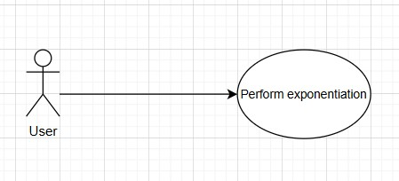

b) Use Case Specification

|  |  |  |  |  |  |
| --- | --- | --- | --- | --- | --- |
| **Use case ID** | **UC.02** | | | | |
| **Use case name** | Perform exponentiation | | | | |
| **Create by** | Van Tu | | **Last updated by** | | Van Tu |
| **Date created** | **March 04, 2025** | | **Date last updated** | | **March 04, 2025** |
| **Actor** | Users of the system | | | | |
| **Description** | This use case describes the process of performing exponentiation operations in the system. | | | | |
| **Trigger** | The user selects the exponentiation function. | | | | |
| **Pre-condition** | The system must be open, and the user must enter valid numeric values. | | | | |
| **Post-condition** | If successful, the system displays the exponentiation result. If unsuccessful, an error message is shown. | | | | |
| **Main Success Scenario:** | **Step** | **Actor Action** | | **System Response** | |
| 1 | The user enters a base number. | | The system registers the input. | |
| 2 | The user selects the exponentiation function (e.g., ^). | | The system waits for the exponent value. | |
| 3 | The user enters an exponent value and presses "=". | | The system calculates and displays the result.. | |
| **Alternative Scenario** | **Step** | **Actor Action** | | **System Response** | |
| 1 | The user enters only one number and presses ^. | | The system prompts the user to enter the exponent value. | |
| 2 | The user provides the missing exponent value. | | The system continues the calculation. | |
| 3 | The system displays the correct result. | | End of use case. | |
| **Exceptions** | **Step** | **Actor Action** | | **System Response** | |
|  | 1 | The user enters an invalid exponent value (e.g., a nonnumeric character). | | The system displays an error message: "Invalid input. Please enter a valid number." | |
|  | 2 | The user enters a base of 0 with an exponent of 0. | | The system displays a warning: "Undefined result." | |
| **Priority** | High | | | | |
| **Business rule** | N/A | | | | |
| **Description:** | This use case ensures that users can perform exponentiation calculations efficiently. It validates user input and handles special cases such as invalid numbers or undefined mathematical operations. | | | | |

UC.06: Perform square root calculation

1. Use Case Diagram

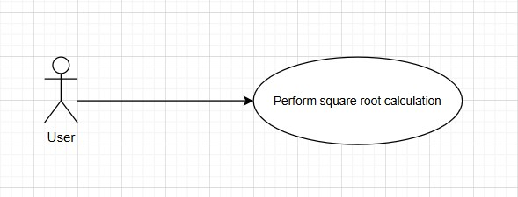

1. Use Case Specification

|  |  |  |  |  |  |
| --- | --- | --- | --- | --- | --- |
| **Use case ID** | **UC.02** | | | | |
| **Use case name** | Perform square root calculation | | | | |
| **Create by** | Van Tu | | **Last updated by** | | Van Tu |
| **Date created** | **March 04, 2025** | | **Date last updated** | | **March 04, 2025** |
| **Actor** | Users of the system, including: General Users | | | | |
| **Description** | This use case describes the process of calculating the square root of a number. | | | | |
| **Trigger** | The user selects the square root function. | | | | |
| **Pre-condition** | The system must be open, and the user must enter a valid numeric value. | | | | |
| **Post-condition** | If successful, the system displays the square root result. If unsuccessful, an error message is shown. | | | | |
| **Main Success Scenario:** | **Step** | **Actor Action** | | **System Response** | |
| 1 | The user enters a number. | | The system registers the input. | |
| 2 | The user selects the square root function (√). | | The system processes the operation. | |
| 3 | The system calculates and displays the square root result. | | End of use case. | |
| **Alternative Scenario** | **Step** | **Actor Action** | | **System Response** | |
| 1 | The user presses the square root button without entering a number. | | The system prompts the user to enter a valid number. | |
| 2 | The user enters a valid number. | | The system processes the operation. | |
| 3 | The system displays the correct result. | | End of use case. | |
| **Exceptions** | **Step** | **Actor Action** | | **System Response** | |
| 1 | The user enters a negative number and presses √.. | | The system displays an error message: "Invalid input. Square root of a negative number is undefined." | |
| 2 | The user enters a non-numeric character and presses √. | | The system displays an error message: "Invalid input. Please enter a valid number." | |
| **Priority** | High | | | | |
| **Business rule** | N/A | | | | |
| **Description:** | This use case ensures that users can perform square root calculations efficiently. It validates user input and handles cases such as negative numbers or non-numeric values. | | | | |

UC.07: Perform percentage calculation

### a) Use Case Diagram

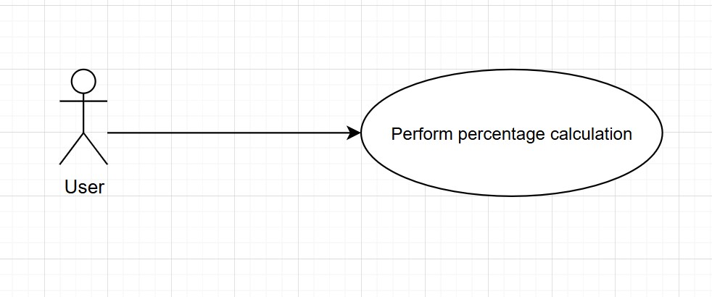

b) Use Case Specification

|  |  |  |  |  |  |
| --- | --- | --- | --- | --- | --- |
| **Use case ID** | **UC.02** | | | | |
| **Use case name** | Perform percentage calculation | | | | |
| **Create by** | Van Tu | | **Last updated by** | | Van Tu |
| **Date created** | **March 04, 2025** | | **Date last updated** | | **March 04, 2025** |
| **Actor** | Users of the system, including: General Users | | | | |
| **Description** | This use case describes the process of calculating a percentage of a given number. | | | | |
| **Trigger** | The user selects the percentage function. | | | | |
| **Pre-condition** | The system must be open, and the user must enter a valid numeric value. | | | | |
| **Post-condition** | If successful, the system displays the percentage result. If unsuccessful, an error message is shown. | | | | |
| **Main Success Scenario:** | **Step** | **Actor Action** | | **System Response** | |
| 1 | The user enters a number. | | The system registers the input. | |
| 2 | The user presses the percentage button (%). | | The system processes the operation. | |
| 3 | The system calculates and displays the percentage result. | | End of use case. | |
| **Alternative Scenario** | **Step** | **Actor Action** | | **System Response** | |
| 1 | The user presses the percentage button without entering a number. | | The system prompts the user to enter a valid number. | |
| 2 | The user enters a valid number. | | The system processes the operation. | |
| 3 | The system displays the correct result. | | End of use case. | |
| **Exceptions** | **Step** | **Actor Action** | | **System Response** | |
| 1 | The user enters a non-numeric character and presses %. | | The system displays an error message: "Invalid input. Please enter a valid number." | |
| 2 | The user enters an extremely large number that exceeds system limits. | | The system displays an error message: "Input exceeds allowable range." | |
| **Priority** | High | | | | |
| **Business rule** | N/A | | | | |
| **Description:** | This use case ensures that users can perform percentage calculations efficiently. It validates user input and handles cases such as missing input or non-numeric values. | | | | |

UC.08: Delete 1 character

1. Use Case Diagram

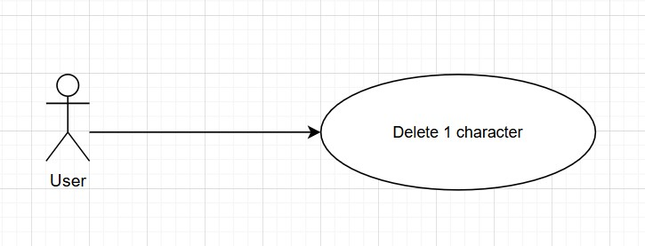

1. Use Case Specification

|  |  |  |  |  |  |
| --- | --- | --- | --- | --- | --- |
| **Use case ID** | **UC.02** | | | |  |
| **Use case name** | Delete 1 character | | | |  |
| **Create by** | Van Tu | | **Last updated by** | | Van Tu |
| **Date created** | **March 04, 2025** | | **Date last updated** | | **March 04, 2025** |
| **Actor** | Users of the system, including: General Users | | | |  |
| **Description** | This use case describes the process of deleting the last character from the current input. | | | | |
| **Trigger** | The user presses the "Delete" or "Backspace" button. | | | | |
| **Pre-condition** | The system must be open, and there must be at least one character in the input field. | | | | |
| **Post-condition** | If successful, the last character is removed. If unsuccessful, the system remains unchanged. | | | | |
| **Main Success Scenario:** | **Step** | **Actor Action** | | **System Response** | |
| 1 | The user enters a number or expression. | | The system registers the input. | |
| 2 | The user presses the "Delete" button. | | The system calculates the result. | |
| 3 | The system updates and displays the modified input. | | End of use case. | |
| **Alternative Scenario** | **Step** | **Actor Action** | | **System Response** | |
| 1 | The user presses the "Delete" button when the input field is empty. | | The system does nothing and remains unchanged. | |
| 2 | The user enters a new input. | | The system registers the new input. | |
| 3 | The user can proceed with calculations. | | End of use case. | |
| **Exceptions** | **Step** | **Actor Action** | | **System Response** | |
| 1 | The user repeatedly presses "Delete" until all characters are removed.. | | The system keeps deleting until the input field is empty. | |
| 2 | The user presses "Delete" again when no characters are left. | | The system does nothing and remains unchanged. | |
| **Priority** | Medium | | | | |
| **Business rule** | N/A | | | | |
| **Description:** | This use case ensures that users can delete characters efficiently while preventing errors when attempting to delete from an empty input field. | | | | |

UC.09: Clear the entire calculation

### a) Use Case Diagram

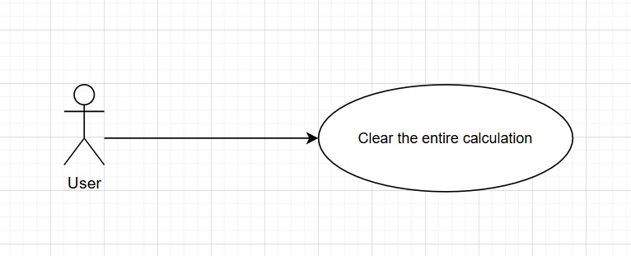

b) Use Case Specification

|  |  |  |  |  |  |
| --- | --- | --- | --- | --- | --- |
| **Use case ID** | **UC.02** | | | | |
| **Use case name** | Clear the entire calculation | | | | |
| **Create by** | Van Tu | | **Last updated by** | | Van Tu |
| **Date created** | **March 04, 2025** | | **Date last updated** | | **March 04, 2025** |
| **Actor** | Users of the system, including General Users | | | | |
| **Description** | This use case describes the process of clearing all entered values and resetting the calculator interface. | | | | |
| **Trigger** | User selects the **"Clear"** button on the calculator interface. | | | | |
| **Pre-condition** | At least one number or operation must be present on the calculator screen | | | | |
| **Post-condition** | If the use case is successful, the calculator screen is completely reset. If unsuccessful, the system remains unchanged. | | | | |
| **Main Success Scenario:** | **Step** | **Actor Action** | | **System Response** | |
| 1 | User clicks the **"Clear"** button. | | The system accepts and displays the input. | |
| 2 | - | | The system clears all entered values and resets the screen to an empty state. | |
| 3 | - | | The system confirms the reset is successful, and the user can start a new calculation. | |
| **Alternative Scenario** | **Step** | **Actor Action** | | **System Response** | |
| 1 | User clicks the **"Clear"** button when no input is present. | | The system does not have enough input to perform subtraction. | |

|  |  |  |  |
| --- | --- | --- | --- |
|  | 2 | - | The system does nothing and remains in the same state. |
| 3 | - | The user can continue using the calculator normally. |
| **Exceptions** | **Step** | **Actor Action** | **System Response** |
| 1 | The system encounters an error while clearing input. | The system displays an error message: **"Unable to clear input. Please try again."** |
| 2 | User clicks **"Clear"** again. | The system successfully clears the input. |
| **Priority** | High | | |
| **Business rule** | N/A | | |
| **Description:** | Users can reset the calculator by clicking the **"Clear"** button, which erases all entered values and resets the display. The system ensures that users can start a fresh calculation without previous inputs interfering. | | |

2.4.6 . Activity Diagrams

Perform addition

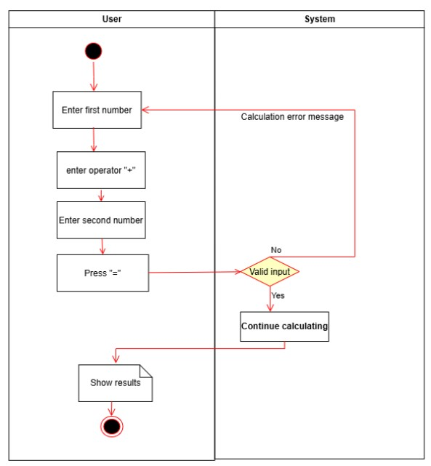

Perform subtraction

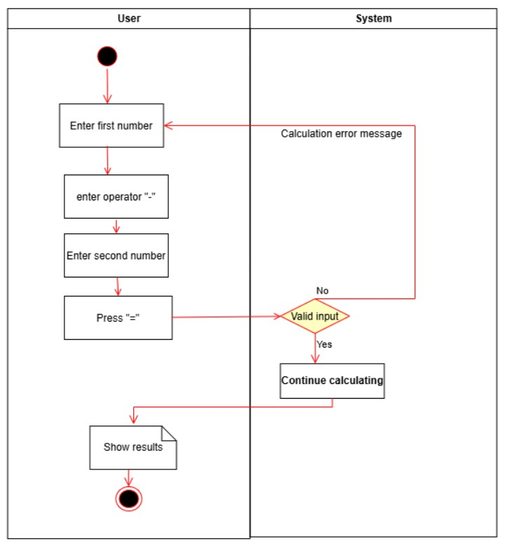

Perform multiplication

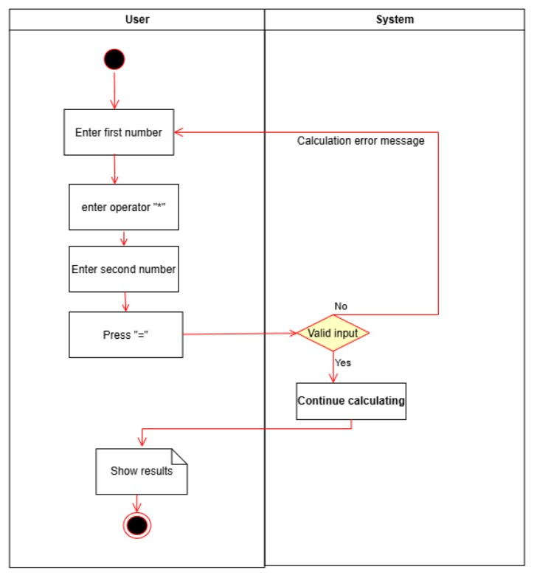

Perform division

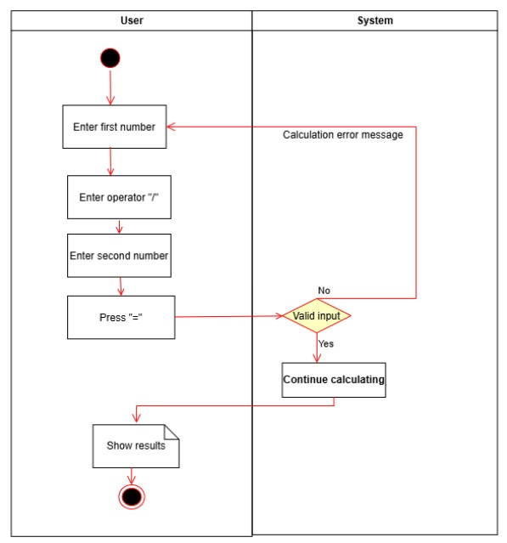

Perform exponentiation

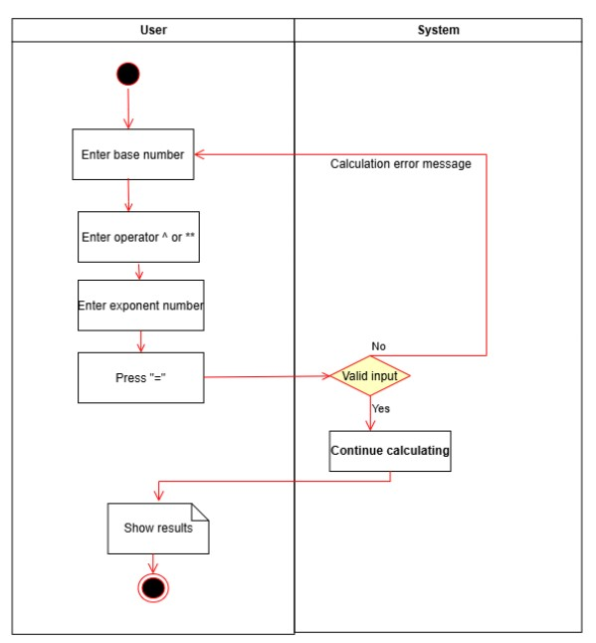

## Perform square root calculation

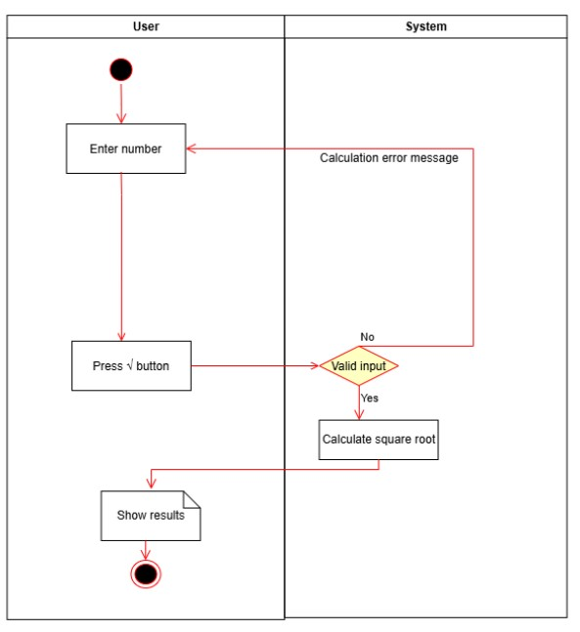

## Perform percentage calculation

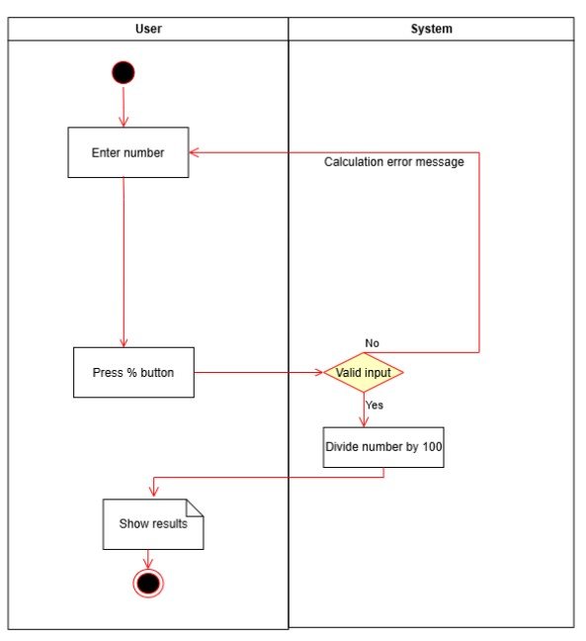

Delete 1 character

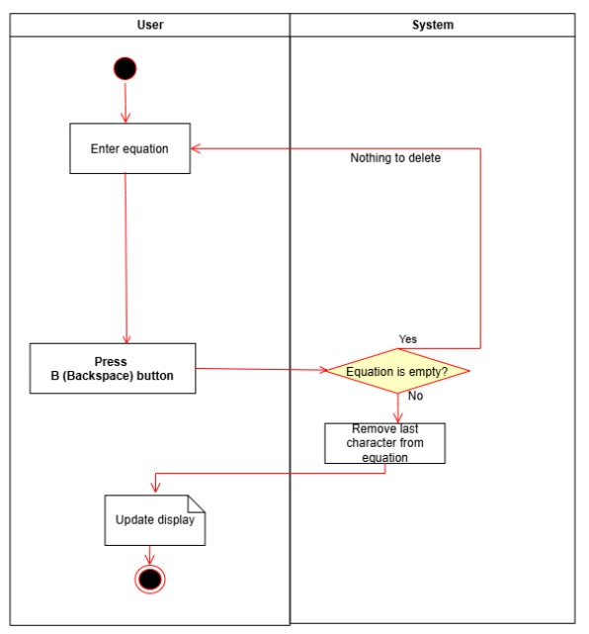

Clear the entire calculation

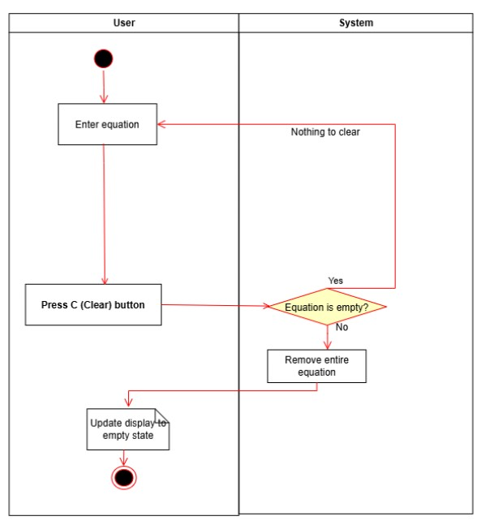

Appendix A: Glossary

|  |  |
| --- | --- |
| FR | **Functional Requirement** |
| QA | Quality Attribute |
| UC | Use case |
| BR | Business rule |